**ASSIGNMENT 1 FRONT SHEET**

|  |  |  |  |
| --- | --- | --- | --- |
| **Qualification** | **BTEC Level 5 HND Diploma in Computing** | | |
| **Unit number and title** | Unit 14: Business Intelligence | | |
| **Submission date** | 03/12/2023 | **Date Received 1st submission** |  |
| **Re-submission Date** |  | **Date Received 2nd submission** |  |
| **Student Name** | BUI TRAN PHUONG THAO | **Student ID** | GCC210031 |
| **Class** | GCC1001 | **Assessor name** | DOAN DINH HO |
| **Student declaration**  I certify that the assignment submission is entirely my own work and I fully understand the consequences of plagiarism. I understand that making a false declaration is a form of malpractice. | | | |
|  |  | **Student’s signature** |  |

**Grading grid**

|  |  |  |  |  |  |
| --- | --- | --- | --- | --- | --- |
| P1 | P2 | M1 | M2 | D1 | D2 |
|  |  |  |  |  |  |

|  |  |  |
| --- | --- | --- |
| **❒ Summative Feedback: ❒ Resubmission Feedback:** | | |
| **Grade:** | **Assessor Signature:** | **Date:** |
| **IV Signature:** | | |

Assessment Brief

|  |  |
| --- | --- |
| Student Name/ID Number |  |
| **Unit Number and Title** | **14: Business Intelligence** |
| Academic Year | 2019-2020 |
| Unit Tutor |  |
| **Assignment Number & Title** | **Assignment 1: Discover business process and BI technologies** |
| **Issue Date** |  |
| Submission Date |  |
| IV Name & Date |  |

|  |
| --- |
| **Submission Format** |
| The submission is in the form of a Microsoft® PowerPoint® style presentation to be presented to your colleagues. The presentation can include links to performance data with additional speaker notes and a bibliography using the Harvard referencing system. The presentation slides for the findings should be submitted with speaker notes as one copy. You are required to make effective use of headings, bullet points and subsections, as appropriate. Your research should be referenced using the Harvard referencing system. The recommended word limit is 500 words, including speaker notes, although you will not be penalised for exceeding the total word limit. |

|  |
| --- |
| **Unit Learning Outcomes** |
| **LO1** Discuss business processes and the mechanisms used to support business decision-making.  **LO2** Compare the tools and technologies associated with business intelligence functionality |
| **Assignment Brief** |

|  |
| --- |
| Your company is currently working in [Assumed Domain] for 2 years. For a new, young company, the competition in the market is very high. Therefore, the Board of Director has decided to apply Business Intelligence to improve the company business process by making better decisions.  The Board of Directors assigns a small group including you in Research & Development Department to study business intelligence to apply for the company in the coming years.  You need to research about business processes and decision support processes in the company and identify the types of data (unstructured, semi-structured or structured) generated by these processes with examples. You also need to research about current software used in the business process or decision support process and evaluate these usages (benefits and drawbacks).  Next you need to understand the types of support for decision-making at different levels (operational, tactical and strategic) within the company and study which business intelligence features can help on that types of support. Study the information systems or technologies (of BI) can be used in this case, compare and contrast them to conclude which should be used.  Your group needs to present the research results to the board in a presentation of 30 minutes. |

|  |  |  |
| --- | --- | --- |
| Learning Outcomes and Assessment Criteria | | |
| Pass | Merit | Distinction |
| **LO1** Discuss business processes and the mechanisms used to support business decision-making | | **D1** Evaluate the benefits and drawbacks of using application software as a mechanism for business processing. |
| **P1** Examine, using examples, the terms ‘Business Process’ and ‘Supporting Processes’. | **M1** Differentiate between unstructured and semi-structured data within an organisation. |
| **LO2** Compare the tools and technologies associated with business intelligence functionality | | D2 Compare and contrast a range of information systems and technologies that can be used to support organisations at operational, tactical and strategic levels. |
| P2 Compare the types of support available for business decision-making at varying levels within an organisation. | M2 Justify, with specific examples, the key features of business intelligence functionality. |

Table of Contents

Assessment Brief 3

I. Introduction 7

II. Discuss business processes and the mechanisms used to support business decision-making (LO1) 7

2.1. Examine, using examples, the terms ‘Business Process’ and ‘Supporting Processes’ (P1). 7

2.1.1. Business Process 7

2.1.2. Classified business process 10

2.1.3. Supporting Processes 14

2.1.4. Talk about the scenario: 15

III. Compare the tools and technologies associated with business intelligence functionality (LO2) 25

3.1. Compare the types of support available for business decision-making at varying levels within an organisation (P2) 25

3.1.1. Decision-making process 25

3.1.2. Type of decision 29

3.1.3. Level of business decision-making: 31

IV. Conclusion 43

References 45

Table

Table 1: Date Generated of Activity Diagram for Payment processing 21

Table 2: Data Generated of Activity Diagram for Online Shopping Processing 23

Table 3: Data Generated of Activity Diagram for Order Processing 25

Table 4: Compare 43

Figure

Figure 1 Dataset: 16

Figure 2: Activity Diagram for Payment processing 20

Figure 3: Activity Diagram for Online Shopping Processing 22

Figure 4: Activity Diagram for Order Processing 24

Figure 5: Operational Decision Workflow for Order Handling 32

Figure 6: Tactical Decision Workflow for Product Management 35

Figure 7: Business Model Evolution and Market Expansion Decision Framework 40

# Introduction

This article focuses on business concepts such as "Retail Online Sales Process". Provide definitions and examples of unstructured and semi-structured data. Overview of some tools and technologies related to smart online retail sales activities. Compare the different levels of support available for business decision-making within a company. Demonstrate the essential elements of business intelligence capabilities using concrete cases. The report is divided into two main parts as follows:

- Sales processes and systems help businesses make decisions

- Compare tools and technologies connected to business intelligence functions.

# Discuss business processes and the mechanisms used to support business decision-making (LO1)

## Examine, using examples, the terms ‘Business Process’ and ‘Supporting Processes’ (P1).

### Business Process

* **Definition:**

A business process is a collection of business tasks and activities that when performed by people or systems in a structured course, produces an outcome that contributes to business goals. In this article, we teach the definition of business processes and look at its advantages, examples, and related business terms.

At its core, a business process is a repeatable collection of steps a company uses to accomplish a goal. Good processes are crucial to making progress toward your goals and improving your business’s operations.

The purpose of a business process is to help your company reach a specific target. If you want to accomplish things as a business, processes allow you to take repeatable, consistent steps forward.

A good process meets three essential criteria:

* **Repeatability:**All processes must be designed to be repeated. A process that you don’t intend to repeat is an action plan instead of a true process. It’s the difference between routine purchases and buying a new facility.
* **Transparency:**Processes also need to be trackable, allowing you to monitor them for success. A good process has built-in data-tracking steps, allowing you to compare performance and efficacy over time.
* **Agility:**Processes that are set in stone don’t hold up in the real world. A process should be adaptable to multiple situations so small changes to the work environment don’t cause delays. Furthermore, a good process should be easy to update in case of more significant or permanent adjustments.
* **Examples:**

Processes vary depending upon the type, industry, location, etc., of a business, but there are a few processes that are practiced across all these segments of businesses around the globe. To make this easy to understand, we will look at examples of such processes.

* + **Sales Process**

Making a sale is a fundamental business process across various industries, offerings, and other segments. The common process observed by most businesses involves the following steps:

* Sharing the sales proposal
* Sending quotes
* Negotiations
* Receiving orders for product/service
* Updating records of sales
* Delivery of product/service
* Billing
* Payment
  + **Customer Service**

Customer service is another important process that is a part of global business operations. It involves the following steps:

* Receive customer complaints/issues through CRM
* Acknowledge the customer concern
* Login details of the issue in the CRM system
* Resolve the issue
* Communicate status to customer

A few more examples of business processes are:

* Recruitment process
* Invoicing process
* Order processing
* Customer onboarding process
* Accounting process
* Market research process
* Product development process

(Blog, 2023)

* **The important**

Business processes help keep your company on task, prevent errors, and increase the speed with which your staff can accomplish their work. Without defined processes, there’s no way to guarantee that anyone does a task the same way twice. Your products or services may not have consistent quality, data may not be collected consistently, and legal documentation may fail to meet regulatory standards.

On the other hand, implementing processes provides consistency, which then allows you to offer higher-quality products, services, and customer service. Well-designed business processes also make your company more efficient. When your staff members understand how they’re supposed to perform tasks, they accomplish them faster and make fewer mistakes.

Efficiency and quality are only two of the benefits of building better business processes. Other advantages of implementing business processes include:

* **Locating opportunities for improvement:** When developing methods and procedures, you must examine your current tactics. In the process, you will both identify existing problems and have the opportunity to fix them. For instance, if your current processes rely on out-of-date technology, you can revise them to include modern alternatives.
* **Reducing costs:** By developing faster and more efficient processes, you can also reduce your company’s expenses. You will both save on direct material costs if you discover ways to minimize waste and indirectly save on payroll as your employees waste less time on inefficient methods.
* **Working toward long-term goals:** A critical step in rewriting your current methods is identifying the tasks your staff must accomplish during their daily routine. You can develop new processes that include actions that progress toward your company’s long-term goals. Taking daily steps toward your targets increases the likelihood that you will achieve those goals in a timely fashion.

(Villanovau, 2023)

### Classified business process

* **Scope of the process in the organization**
* **Individual process**
  + **Definition:** An individual process refers to a specific task or set of tasks that are carried out by a single person within the organization.
  + **Scope**
  + **Responsibilities:** This process involves the responsibilities assigned to an individual employee. It could be a routine task or a specialized function depending on the employee's role.
  + **Accountability:** The individual is accountable for the successful completion of the tasks assigned to them within this process.
  + **Efficiency:** The efficiency of individual processes is crucial for overall organizational effectiveness. Improving efficiency in these tasks contributes to the organization's productivity.

(Homework, 2023)

* **Vertical process**
  + **Definition:** A vertical process, also known as a "top-down" or "up-and-down" process, involves activities or tasks that cut across different hierarchical levels within the organization.
  + **Scope**
* **Coordination:** Vertical processes involve coordination between different levels of management, ensuring that goals and information flow seamlessly from top to bottom and vice versa.
* **Decision-Making:** Critical decisions often involve multiple levels of management. Vertical processes facilitate the flow of information required for decision-making at various organizational levels.
* **Communication:** Communication within vertical processes ensures that strategic objectives are aligned with the operational tasks at different levels of the organization.

(Homework, 2023)

* **Horizontal process**
  + **Definition:** A horizontal process, also known as a "cross-functional" or "end-to-end" process, encompasses activities that cut across various functional departments or units within the organization.
  + **Scope**
  + **Collaboration:** Horizontal processes require collaboration between different departments, as they involve tasks that span multiple functions.
  + **Efficiency and Streamlining:** Streamlining horizontal processes can lead to improved efficiency, as it helps eliminate redundancies and bottlenecks that may occur when different departments work in isolation.
  + **Customer-Centric**: Many horizontal processes are customer-centric, focusing on delivering value to customers by integrating various functions to meet their needs seamlessly.

(Homework, 2023)

**Integration:**

* Interconnectedness: In practice, these processes are not mutually exclusive. Individual processes contribute to vertical and horizontal processes, forming an intricate web of organizational activities.
* Organizational Goals: The integration of these processes is essential for achieving organizational goals. Effective coordination between individual, vertical, and horizontal processes ensures a cohesive and well-functioning organization.
  + **Purpose of the process:**
* **Supporting Processes**
  + **Definition:** Supporting processes, often referred to as auxiliary or secondary processes, are activities that facilitate the smooth operation of the core functions within an organization.
  + **Purpose:**
  + **Resource Management:** Supporting processes aim to efficiently manage and allocate resources such as human resources, financial assets, and technological infrastructure to ensure optimal functioning.
  + **Risk Mitigation:** These processes often include risk management activities, focusing on identifying potential risks and implementing strategies to mitigate or manage them.
  + **Compliance:** Supporting processes play a crucial role in ensuring that the organization adheres to regulatory requirements, industry standards, and internal policies.

(Healthit, 2023)

* **Operational Processes**
  + **Definition:** Operational processes are the core business activities that directly contribute to the creation and delivery of goods or services.
  + **Purpose:**
  + **Value Creation:** The primary purpose of operational processes is to create value for the organization by producing goods or delivering services that meet customer needs.
  + **Efficiency:** Operational processes are designed to be efficient, ensuring that resources are utilized effectively to achieve desired outcomes in terms of quality, quantity, and timeliness.
  + **Innovation:** Continuous improvement and innovation are often embedded in operational processes to enhance products or services and stay competitive in the market.

(Process, 2023)

* **Management Processes** 
  + **Definition:** Management processes are activities that focus on planning, organizing, directing, and controlling the organization's resources to achieve its strategic objectives.
  + **Purpose:**
  + **Strategic Planning:** Management processes involve strategic planning to set long-term goals, define organizational objectives, and develop plans for achieving them.
  + **Leadership and Direction:** These processes provide leadership and direction to the organization, guiding employees toward common goals and ensuring alignment with the overall mission.
  + **Performance Monitoring and Evaluation:** Management processes include monitoring and evaluating organizational performance against predefined metrics, allowing for adjustments and improvements.

(Process, 2023)

**Integration:**

* **Interconnectedness:** These three types of processes are interdependent. Supporting processes provide the necessary foundation for operational processes to function effectively, and management processes oversee and guide both supporting and operational activities.
* **Alignment with Goals:** Together, these processes contribute to the alignment of organizational activities with strategic goals, fostering a well-coordinated and goal-oriented environment.
* **Continuous Improvement:** An organization's ability to thrive is often contingent on its capacity to continuously improve all three types of processes. Management ensures strategic evolution, supporting processes provide the necessary infrastructure, and operational processes drive innovation and value creation.

### Supporting Processes

Supporting processes refer to activities within an organization that, while not directly contributing to the core business objectives, are crucial for facilitating and optimizing the overall operations. These processes provide the necessary infrastructure and support to ensure the smooth functioning of core business processes.

* + **Definition:** Supporting processes are those activities and functions that enable and facilitate the execution of core business processes. They contribute indirectly to the production of goods or services by providing the necessary support and resources.
  + **Examples of Supporting Processes:**
* **Human Resource Management (HRM**): Recruitment, training, and employee management.
* **Information Technology (IT) Support:** Providing technical assistance and maintaining IT infrastructure.
* **Administrative Processes:** Document management, scheduling, and office logistics.
* **Finance and Accounting:** Budgeting, financial reporting, and expense management.
  + **Importance of Supporting Processes:** Supporting processes play a vital role in organizational success by:
  + Enhancing Efficiency: Streamlining internal operations.
  + Ensuring Compliance: Adhering to regulations and standards.
  + Improving Customer Satisfaction: Facilitating smooth customer interactions.
  + Enabling Innovation: Creating a stable foundation for innovation.
  + Optimizing Resources: Efficient use of human and technological resources.

Supporting processes are integral to the success of any organization as they play a pivotal role in optimizing operations and ensuring overall efficiency. These processes contribute to enhanced resource allocation, risk management, and compliance with regulatory standards. By streamlining various aspects of business functions, supporting processes facilitate quality assurance, customer satisfaction, and innovation. Additionally, they enable effective data management, analysis, and adaptation to changes in the business environment. Supporting processes also prioritize employee development, fostering a skilled and motivated workforce. In essence, these processes form the foundation for sustained growth, resilience, and continuous improvement within an organization.

(Global, 2023)

### Talk about the scenario:

* **Scenario:** The Coder Uppers is a prominent U.S. online retailer, is gearing up for the festive season and the accompanying surge in customer orders. With a comprehensive dataset focused on holiday order fulfillment, including order details, customer demographics, and logistics specifics, the company aims to optimize operations. The seamless process involves customers navigating the user-friendly platform, swift inventory checks, meticulous order processing, and efficient logistics coordination. Through visual representations and data analysis, The Coder Uppers is committed to ensuring a joyful and seamless shopping experience for its customers during this busy holiday period.
* **Deep introduction:**

The Coder Uppers is a prominent online retail platform in the United States, is gearing up for a busy holiday season. With a vast array of products ranging from electronics to fashion and home goods, the company expects a surge in orders. This scenario focuses on the order fulfillment process, a critical aspect of The Coder Uppers operations during this peak period.

* **Present part of data set**

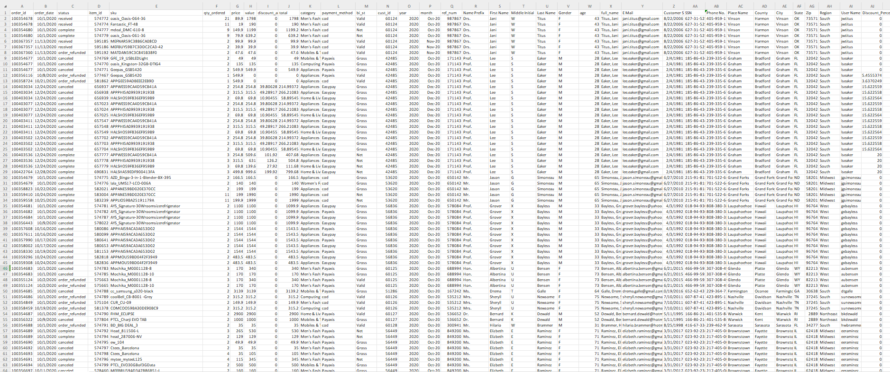

Figure 1 Dataset:

* **Explain dataset**

**Describe company and datasets in this project:**

Link datasets: <https://www.kaggle.com/datasets/ytgangster/online-sales-in-usa>

E-Shop Express, the focal company in this project, operates as an e-commerce platform in the United States, specializing in a diverse array of products such as electronics, clothing, home goods, appliances, mobiles & tablets, and more. The company's online sales activities are extensively captured in the datasets obtained. These datasets encompass vital details including order information (order ID, date, status), product details (item ID, SKU, quantity, pricing, discounts), payment and billing specifics (payment method, billing status), customer information (customer ID, demographics, contact details), and temporal aspects (year, month) among others.

The datasets provide an opportunity for comprehensive analysis. Potential insights can be derived through examining sales performance, understanding customer behavior, optimizing operational processes, assessing geographic distribution, and refining marketing strategies. By leveraging this rich dataset, The Coder Uppers can make informed decisions to enhance its offerings, improve customer satisfaction, and achieve operational efficiency in the competitive landscape of the online retail sector.

The dataset provides comprehensive information related to customer orders and transactions within the E-Shop Express platform. Here's a breakdown of the key columns in the dataset:

* **Order Information:**
  + **order_id**: A unique identifier assigned to each order made by customers.
  + **order_date**: The date when the customer placed the order.
  + **status**: Indicates the current status of the order (e.g., received, complete, order_refunded, canceled).
* **Product nformation:**
  + **item_id**: A unique identifier for each item in the order.
  + **sku**: The Stock Keeping Unit, a distinct identifier for each product variant.
  + **qty_ordered**: The quantity of a specific item ordered.
  + **price**: The unit price of the item.
  + **value**: The total value of the order for a particular item.
  + **discount_amount**: The amount of discount applied to the item.
  + **total**: The total amount for the item after discount.
* **Product Details:**
  + **category**: The category of the product, providing insights into the type of items customers are purchasing (e.g., Men's Fashion, Mobiles & Tablets, Appliances).
* **Payment and Billing Information:**
  + **payment_method**: Indicates the payment method used for the order (e.g., cod, Payaxis, Easypay).
  + **bi_st**: Billing status, specifying whether the billing is considered valid or if it's gross or net.
* **Customer Information:**
  + **cust_id**: A unique identifier for each customer.
  + **year** and **month**: The temporal information indicating when the customer engaged with the platform.
  + **ref_num**: A reference number associated with the customer.
  + **Name Prefix**, **First Name**, **Middle Initial**, **Last Name**, **Gender**, **age**: Demographic details of the customer.
  + **full_name**: The complete name of the customer.
  + **E Mail**: The email address of the customer.
  + **Customer Since**: The date when the customer started engaging with E-Shop Express.
  + **SSN**: The Social Security Number of the customer (masked for privacy).
  + **Phone No.**: The phone number of the customer.
* **Address Information:**
  + **Place Name**, **County**, **City**, **State**, **Zip**, **Region**: Details about the customer's location.
* **User Account Information:**
  + **User Name**: The username associated with the customer's account.
  + **Discount_Percent**: The percentage of discount applied to the order.

This dataset captures the entire lifecycle of customer orders, providing a detailed view of the products, payments, customer demographics, and addresses. The information is diverse, enabling a thorough analysis of business processes, customer behavior, and order fulfillment within E-Shop Express.

* **List of bussiness process in the scenario**

The Coder Uppers engages in a series of interconnected business processes to effectively operate its e-commerce platform in the United States. The company manages comprehensive processes such as order fulfillment, inventory control, and product catalog maintenance. Customer-centric processes include relationship management, payment processing, and the handling of returns and refunds. Marketing and promotional activities, logistics and shipping coordination, as well as robust security and fraud prevention measures, are integral to the company's operations. The Coder Uppers also focuses on customer onboarding, data analytics, and reporting for informed decision-making. Supplier and vendor relationships, user account management, and analyses of seasonal and market trends contribute to the company's overall success. These processes collectively ensure a seamless and competitive operation within the dynamic landscape of online retail.

• Online Pay process

• Customer service process

• Marketing strategy process

• Staff training and development process

• Business strategy process

• Competitive analysis process

• Shipping and delivery

• process of ordering online and the process of processing orders

• warehousing process

• the product management process on the system

• Develop website process

* **Activity diagram for the bussiness process in the scenario**
  + **Activity Diagram for Payment processing**

### 

Figure 2: Activity Diagram for Payment processing

### The user must first log in to the system by entering their account password in order to pay for an order placed on the website. Subsequently, the system will verify the validity of the user's account. The application will notify the user and prompt them to log in again from the beginning if it is invalid. Conversely, the application will provide users the option to select payment methods like easy pay, payaxis, and cod. The system will then verify the payment information. The application will indicate an error and prompt the user to choose a different payment option if the payment confirmation is inaccurate. The user data will be updated by the system upon accurate confirmation.

**Data Generated**

|  |  |  |
| --- | --- | --- |
| **Unstructured Data** | **Semi-Structure Data** | **Structured Data** |
| **- Source**: Consumer comments about the product in the dialogue box for reviews and comments.  **-Explanation:** Collects opinions and subjective insights about the payment process and suggests possible areas for development. | **- Source:** Payment information, such as modes of payment (COD, Pay Axis, Easy Pay), and other irregular data that complies with regulations.  **- Explanation:** Maintains organized components while handling a variety of payment methods, guaranteeing safe and adaptable financial transactions. | **- Source:** Structured database tables hold order information such as order number (order_id), order date (order_date), price (price), and total value (total).  **- Explanation:** forms the basis of financial transactions by offering organized and consistent data for smooth payment processing, retrieval, and analysis. |

Table 1: Date Generated of Activity Diagram for Payment processing

* **Activity Diagram for Online Shopping Processing**

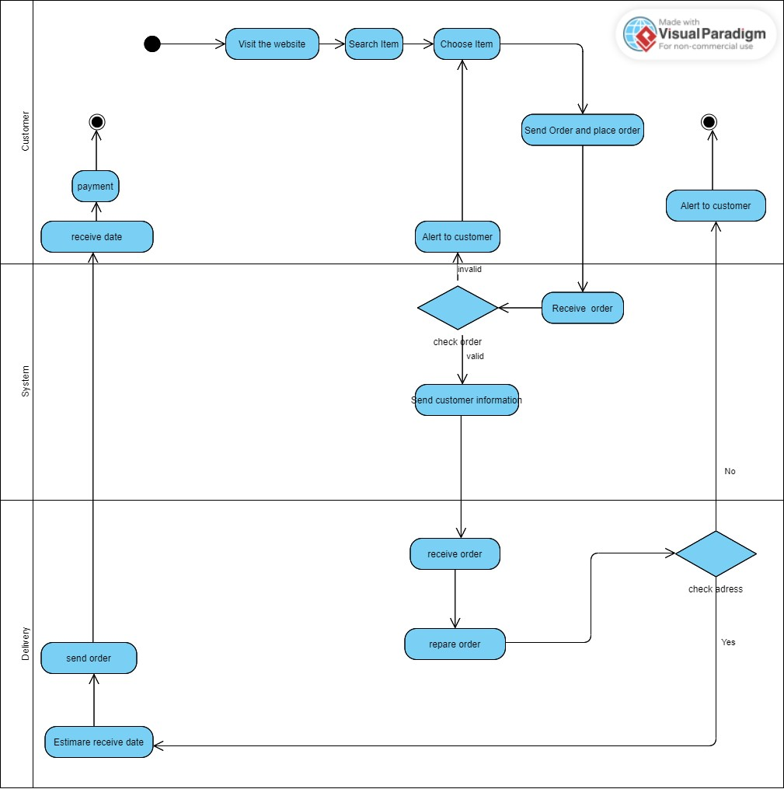

Figure 3: Activity Diagram for Online Shopping Processing

The diagram below shows the steps involved in online shopping. Within the system, each Customer, System, and Distribution will operate as a distinct stream. Customers first come to our online store to look for products they want to buy. Customers can choose their items, add them to their carts, and check out. Information from customers, including name, address, phone number, and email, is requested. Next, the system verifies if the items are in stock by looking up the order.

The customer is prompted by the system to select alternative items or make a later return if the store is out of stock, rendering their order invalid. The system forwards the order details to the shipping department for address validation if the order is legitimate. After receiving the order, the delivery staff prepares the goods and confirms the customer's address. They advise the client if the address is inaccurate. If accurate, the delivery staff starts the delivery and estimates the customer's delivery date. Finally, if the customer opted to pay upfront, they will proceed with payment once they receive the order.

**Data Generated**

|  |  |  |
| --- | --- | --- |
| **Unstructured Data** | **Semi-Structured Data** | **Structured Data** |
| - **Source:** Reviews and remarks left by customers on a product's website.  **- Explanation:** involves textual data with no set structure, enabling users to freely express their opinions and choices regarding the product. These unstructured data offer personal perspectives. | - **Source:**  JSON file containing product information.  **- Explanation:** makes use of JSON data and structure files such as "product_id" and "product_name," while leaving room for more information. A variety of product information can be accommodated by this semi-structured format. | **- Source:** Database records in an SQL database.  **- Explanation:** involves defined files with fields like "customer_id," "customer_name," "customer_email," and "customer_address" that are used to organize structured data in database records. In managing customer information, this structured format guarantees consistency and ease of retrieval. |

Table 2: Data Generated of Activity Diagram for Online Shopping Processing

* **Activity Diagram for Order Processing**

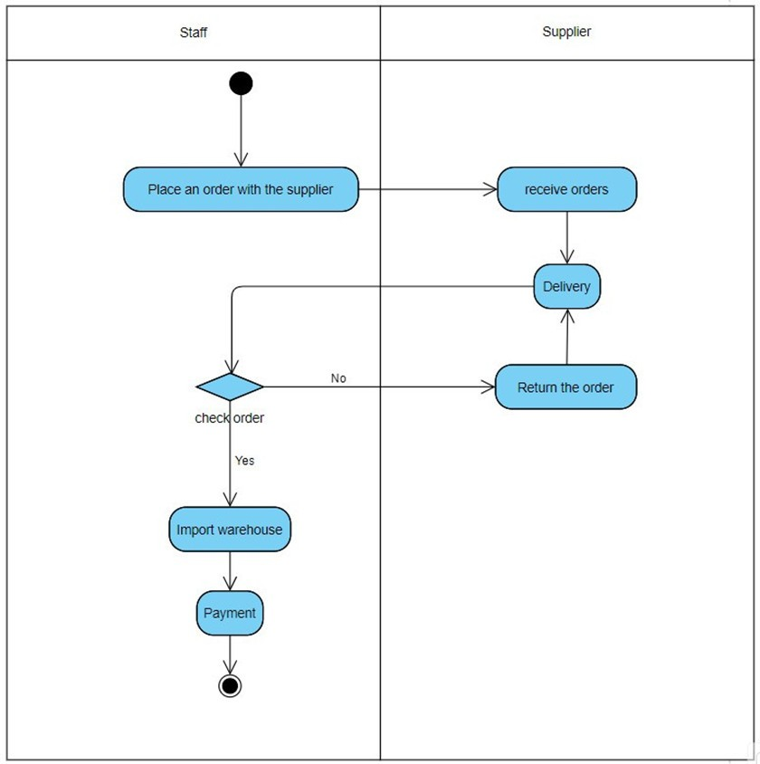

Figure 4: Activity Diagram for Order Processing

Employee users place orders with suppliers to start the process of replenishing inventory when necessary. The supplier gets the items ready after receiving the order. The supplier makes arrangements for delivery as soon as there is enough inventory. Workers check the order against the submitted request after the goods are delivered. If there are differences, the supplier receives the incorrect orders back, and the warehouse employees inventory the items and pay the supplier.

**Data Generated**

|  |  |  |
| --- | --- | --- |
| **Unstructured Data** | **Semi-Structured Data** | **Structured Data** |
| **- Source:** Informal email exchanges while placing orders.  **- Explanation:** Email content may contain unstructured data that is not in a predetermined format. Informal communications between staff members and vendors may include unstructured data, like extra order instructions or unique requests. | **- Source:** JSON file containing order information during the process.  **- Explanation:** A JSON file with the order details could be used to represent semi-structured data. There may be flexibility for additional details or customer notes, allowing for some variation, even though some files, like "order_id" and "supplier_name," maintain a structured format. | **- Source:** Database records in an SQL databse for order processing.  **- Explanation:** Order details are arranged into records with defined files such as "order_id," "supplier_id," "item_id," "quantity_ordered," and "delivery_status" using structured data that is kept in a database. The organized arrangement guarantees uniformity and expedites the efficient retrieval and administration of order-related data. |

Table 3: Data Generated of Activity Diagram for Order Processing

# Compare the tools and technologies associated with business intelligence functionality (LO2)

## Compare the types of support available for business decision-making at varying levels within an organisation (P2)

### Decision-making process

* **Overview of Decision-making process**

The business decision-making process is a step-by-step process allowing professionals to solve problems by weighing evidence, examining alternatives, and choosing a path from there. This defined process also provides an opportunity, at the end, to review whether the decision was the right one.

The decision making process is the method of gathering information, assessing alternatives, and, ultimately, making a final choice.

The following seven step process is intended for challenging decisions that involve multiple [stakeholders](https://asana.com/resources/project-stakeholder), but this process can be used for something as simple as what cereal to pour into your breakfast bowl in the morning.

(Lucidchart, 2023)

(Umassd, 2023)

* **The 7 steps of the decision making process**
* Step 1: Identify the decision that needs to be made. When you're identifying the decision, ask yourself a few questions:
* What is the problem that needs to be solved?
* What is the goal you plan to achieve by implementing this decision?
* How will you measure success?

These questions are all common goal setting techniques that will ultimately help you come up with possible solutions. When the problem is clearly defined, you then have more information to come up with the best decision to solve the problem.

* **Step 2: Gather relevant information**

​Gathering information related to the decision being made is an important step to making an informed decision. Does your team have any historical data as it relates to this issue? Has anybody attempted to solve this problem before?

It's also important to look for information outside of your team or company. Effective decision making requires information from many different sources. Find external resources, whether it’s doing market research, working with a consultant, or talking with colleagues at a different company who have relevant experience. Gathering information helps your team identify different solutions to your problem.

* **Step 3: Identify alternative solutions**

This step requires you to look for many different solutions for the problem at hand. Finding more than one possible alternative is important when it comes to business decision-making, because different stakeholders may have different needs depending on their role. For example, if a company is looking for a work management tool, the design team may have different needs than a development team. Choosing only one solution right off the bat might not be the right course of action.

* **Step 4: Weigh the evidence**

This is when you take all of the different solutions you’ve come up with and analyze how they would address your initial problem. Your team begins identifying the pros and cons of each option, and eliminating alternatives from those choices.

There are a few common ways your team can analyze and weigh the evidence of options:

* Pros and cons list
* SWOT analysis
* Decision matrix
* **Step 5: Choose among the alternatives**

The next step is to make your final decision. Consider all of the information you've collected and how this decision may affect each stakeholder.

Sometimes the right decision is not one of the alternatives, but a blend of a few different alternatives. Effective decision-making involves creative problem solving and thinking out of the box, so don't limit you or your teams to clear-cut options.

One of the key values at Asana is to reject false tradeoffs. Choosing just one decision can mean losing benefits in others. If you can, try and find options that go beyond just the alternatives presented.

* **Step 6: Take action**

Once the final decision maker gives the green light, it's time to put the solution into action. Take the time to create an implementation plan so that your team is on the same page for next steps. Then it’s time to put your plan into action and monitor progress to determine whether or not this decision was a good one.

* **Step 7: Review your decision and its impact (both good and bad)**

Once you’ve made a decision, you can monitor the success metrics you outlined in step 1. This is how you determine whether or not this solution meets your team's criteria of success.

Here are a few questions to consider when reviewing your decision:

* Did it solve the problem your team identified in step 1?
* Did this decision impact your team in a positive or negative way?
* Which stakeholders benefited from this decision? Which stakeholders were impacted negatively?
* If this solution was not the best alternative, your team might benefit from using an iterative form of project management. This enables your team to quickly adapt to changes, and make the best decisions with the resources they have.
* **Challenges in the Decision-Making Process**
* **Incomplete Information:**
* **Challenge:** Understand that complete information is not always available, and making decisions based on incomplete information can lead to inadequate analysis and potential errors.
* **Solution:** Increase efforts to gather information from various sources. Use media, research, and assess the reliability of information.
* **Decision Bias:**
* **Challenge:** The influence of personal biases can skew decisions and lead to suboptimal choices.
* **Solution:** Be aware of personal biases and approach the decision-making process objectively. Use bias control methods and consider perspectives from different angles.
* **Risk and Uncertainty:**
* **Challenge:** Many decisions involve risk or uncertainty. Predicting future outcomes can be challenging.
* **Solution:** Use risk analysis techniques, identify feasible scenarios, and assess the level of uncertainty. Apply strategies to minimize the impact of risks.
* **Group Dynamics:**
* **Challenge:** Managing conflicting opinions in group decision-making and ensuring effective communication can be challenging.
* **Solution:** Promote openness and constructive discussion. Use relationship management tools and teamwork techniques to address conflicts.
* **Emotional Influences:**
* **Challenge:** Emotions can cloud judgment, and decisions made under the influence of stress or strong emotions may be irrational.
* **Solution:** Ensure good mental well-being and use stress control techniques. Consider making decisions after being calm and applying emotional control processes.
* **Time Constraints:**
* **Challenge:** Decisions need to be made quickly, leaving little time for detailed analysis and review.
* **Solution:** Optimize the decision-making process by prioritizing important tasks and using an efficient decision-making procedure.
* **Overcoming Resistance to Change:**
* **Challenge:** There may be resistance from individuals or groups not in favor of the decision.
* **Solution:** Clearly communicate the purpose of the decision, address concerns, and encourage involvement from relevant parties.
* **Cultural and Ethical Considerations:**
* **Challenge:** Decisions may face cultural or ethical issues, requiring careful consideration.
* **Solution:** Understand cultural values and ethical principles. Seek input from individuals with cultural expertise to ensure decisions satisfy all involved parties.

### Type of decision

* **Structured Decision:**

Structured decisions are characterized by routine and repetitive tasks that follow predefined procedures. An example is the process of reordering office supplies when the inventory falls below a specified level. Business Intelligence (BI) features tailored for structured decisions include dashboard reporting, offering real-time visibility into inventory levels. Additionally, alerts and notifications are integrated to notify relevant personnel when inventory reaches a reorder point. Tools and techniques commonly employed for structured decisions involve Enterprise Resource Planning (ERP) systems equipped with built-in reporting modules, ensuring a streamlined and efficient workflow.

* + - * **Characteristics:** Routine and repetitive, typically following predefined procedures.
      * **Example:** Reordering office supplies when inventory falls below a certain level.
      * **BI Features:**

**Dashboard Reporting:** Provides real-time visibility into inventory levels.

**Alerts and Notifications:** Alerts when inventory reaches a reorder point.

* + - * **Tools/Techniques:** ERP systems with built-in reporting modules.
* **Unstructured Decision:**

Unstructured decisions are intricate, lacking clear definitions, and demanding creativity and intuition. An example is the development of a new marketing strategy for a product launch. BI features suitable for unstructured decisions include data visualization tools that help identify patterns and trends in consumer behavior. Predictive analytics is also crucial for forecasting potential market responses. Advanced analytics tools like Tableau or Power BI are commonly utilized in this context, providing the necessary flexibility and insight to navigate the complexity of unstructured decision-making.

* + - * **Characteristics:** Complex and not easily defined, requiring creativity and intuition.
      * **Example:** Developing a new marketing strategy for a product launch.
      * **BI Features:**

**Data Visualization:** Helps identify patterns and trends in consumer behavior.

**Predictive Analytics:** Forecasts potential market responses.

* + - * **Tools/Techniques:** Advanced analytics tools like Tableau or Power BI.
* **Semi-Structured Decision:**

Semi-structured decisions encompass elements of both routine and creative decision-making processes. An example is the selection of a vendor for a new product component. BI features tailored for semi-structured decisions include ad hoc reporting, allowing for flexible exploration of vendor performance data. Collaboration tools are essential to facilitate communication and information sharing among stakeholders involved in the decision-making process. Business Intelligence platforms equipped with ad-hoc reporting and collaboration features play a pivotal role in addressing the unique challenges presented by semi-structured decisions, ensuring a balanced and informed approach.

* + - * **Characteristics:** Involves elements of both routine and creative decision-making.
      * **Example:** Selecting a vendor for a new product component.
      * **BI Features:**

**Ad Hoc Reporting:** Allows for flexible exploration of vendor performance data.

**Collaboration Tools:** Facilitates communication and information sharing.

* + - * **Tools/Techniques:** Business Intelligence platforms with ad-hoc reporting and collaboration features.

### Level of business decision-making:

* **Operational Decisions**

**Operational Decision Workflow for Order Handling**

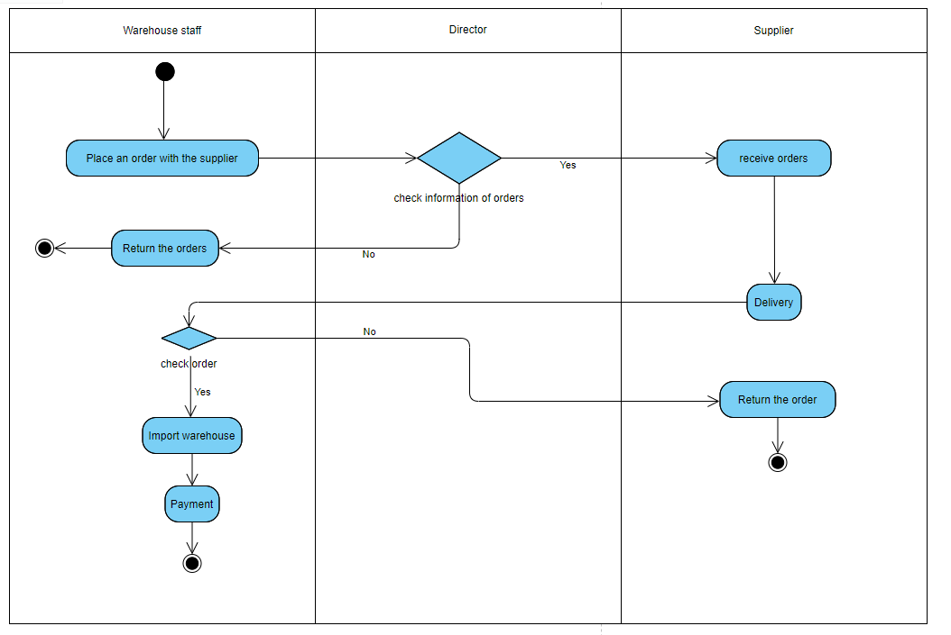

Figure 5: Operational Decision Workflow for Order Handling

Starting with the Warehouse Staff's job is to place an order with the suplier, then move to Direcotr to check information of orders. If there is no, the Director will return the orders to the Warehouse Staff and end with the Warehouse Staff. If yes, the Supplier will receive. orders and suplier will Deliver, and pass it on to Warehouse Staff to check the order. If there are any errors, Warehouse Staff will return the order to the Supplier. and Supplier and ends at Supplier. If the warehouse staff check order is reasonable and returns yes, it will import warehouse and then pay and the end at warehouse staff.

* **Place Order**
* **Characteristics:** Start the process by placing an order from Warehouse Staff.
* **Example**: Warehouse Staff places an order to upgrade inventory.
* **BI Features:**

**Data Visualization:** BI can display graphs of order history to predict the next order level.

**Reporting Tools:** Report on order trends and delivery times.

* **Director Checks Orders**
* **Characteristics:** Director checks order information.
* **Example**: The Director checks orders to ensure quality and accuracy.
* **BI Features:**

**Data Analysis**: Analyze quality data and order accuracy using BI.

**Alerts:** Alerts if there are any problems with the order.

* **Supplier Receives and Delivers**
* **Characteristics:** Supplier receives orders and delivers goods.
* **For example:** Supplier receives orders and delivers goods as requested.
* **BI Features:**

**Supply Chain Analytics:** Track supplier performance and delivery times.

**KPI Monitoring:** Monitor key supplier performance indicators.

* **Warehouse Staff Checks Order**
* **Characteristics:** Warehouse Staff checks orders after receiving them.
* **For example:** Warehouse Staff detects an error or omission in an order.
* **BI Features:**

**Inventory Analytics:** Analyze inventory data to identify errors.

**Visualization:** Charts of inventory status and detected errors.

* **Import to Warehouse**
* **Characteristics:** Insert goods into the inventory system.
* **For example:** Goods are entered into the warehouse's inventory system.
* **BI Features:**

**Data Integration:** Integrate data with the warehouse management system.

**Predictive Analytics:** Predict inventory needs based on historical data.

* **Payment**
* **Characteristics**: Decide on payment for the order.
* **For example:** Warehouse Staff initiates the payment process.
* **BI Features:**

**Financial Analytics**: Track and analyze payment history.

**Budgeting Tools**: Predict costs based on historical data.

* **Compare BI Tools:**
* **Tableau vs. Power BI:** Both are powerful at creating charts and reports, but Power BI integrates strongly with Microsoft technologies, while Tableau has greater flexibility for multi-source data sources.
* **SAP Analytics Cloud vs. Oracle Analytics:** Both provide comprehensive solutions from business decisions to detailed analysis, but SAP typically focuses on integration with ERP solutions, while Oracle focuses on integration with databases Oracle and business applications.
* **QlikView vs. Looker:** QlikView is often known for its flexible data analytics capabilities, while Looker focuses on creating flexible and interactive dashboards.
* **Tactical Decisions**

**Tactical Decision Workflow for Product Management**

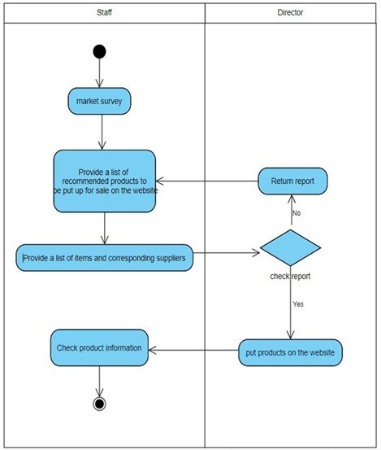

Figure 6: Tactical Decision Workflow for Product Management

This diagram represents the store's one-year product planning. Start work in Staff and then do Market survey, continue after that with Provide a list of recommended products to be put for sale on the website, continue in Staff and the next job is Provide a list of items and corresponding suppliers and then send it to the Director to check and check report. If the result is no, the report will be returned to the Staff and the Staff will continue the work. Provide a list of recommended products to be put for sale on the previous website done until the result returns the value yes. If the result is yes, the Director will put products on the website, and besides that it will send to the Staff so that the Staff can check the product information and it ends at Staff.

Market Survey

* **Market Survey:**
* **Characteristics:** Conduct market surveys to assess needs and trends.
* **Example:** Staff conducts market surveys to identify hot products.
* **BI Support:**

**Data Analytics**: Analyze market data to identify trends.

**Predictive Analytics:** Predict future demand based on historical data.

* **Provide a List of Recommended Products:**
* **Features:** Create a list of recommended products for sale on the website.
* **Example:** Staff builds a list of recommended products based on survey results.
* **BI Support:**

**Data Visualization**: Display charts and reports about recommended products.

**Reporting Tools**: Create detailed reports about product lists.

* **Provide a List of Items and Corresponding Suppliers:**
* **Characteristics:** List items and corresponding suppliers.
* **Example:** Staff creates item list and supplier information.
* **BI Support:**

**Supplier Analytics:** Track supplier performance and pricing.

**Data Integration:** Combine data from multiple sources about products and suppliers.

* **Check Report by Director:**
* **Characteristics:** Check report by Director.
* **Example:** Director checks the report and evaluates its reasonableness.
* **BI Support:**

**Reporting Tools:** Comprehensive reports on products and performance.

**Alerts:** Warn if there are problems that need to be resolved.

* **Put Products on Website:**
* **Characteristics:** Put products on the website for sale.
* **For example:** Director puts products on the sales list.
* **BI Support:**

**E-commerce Analytics:** Track sales and customer feedback.

**Data Visualization:** Visual display of sales.

* **Check Product Information:**
* **Characteristics:** Staff checks product information on the website.
* **Example**: Staff ensures that product information on the website is accurate.
* **BI Support:**

**Quality Control Analytics:** Monitor the quality of product information.

**Visualization:** Charts of performance and information quality.

* **Compare BI Tools:**
* **Data Analytics:**

**Tableau vs. Power BI:** Power BI has good integration with Microsoft products, while Tableau is often appreciated for its ability to analyze multiple data sources.

* **Predictive Analytics:**

**SAP Analytics Cloud vs. Oracle Analytics:** Both provide predictive capabilities, however, SAP has the edge when it comes to integration with ERP solutions.

* **Supplier Analytics:**

**QlikView vs. Looker**: QlikView is highly flexible in terms of data statistics and data integration from various sources, while Looker focuses on data interaction and visualization.

* **Strategic Decisions**

**Business Model Evolution and Market Expansion Decision Framework**

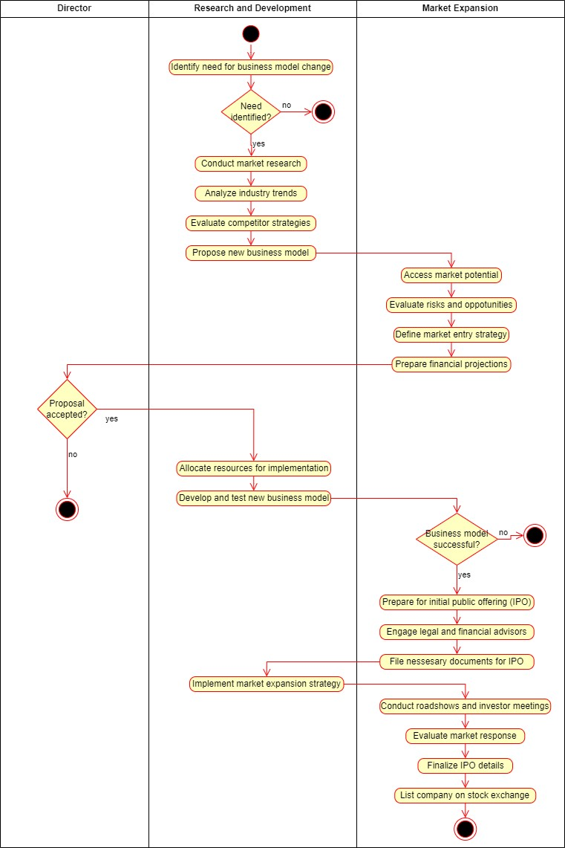

Figure 7: Business Model Evolution and Market Expansion Decision Framework

This diagram outlines the store's 20-year plan with three main sections: Starting a job at Research and Development, and also a job at Research and Development is Identify need for business model change, and still at Research Development is Need identify? If the return value is no, it will end up at Research and Development. If the return value is yes, then Research and Development will continue to perform Conduct martket research. Still at Research and Development, continue to work on Analyze industry trends, and then Propose new business model at Research and Development. Then the work will be transferred to Market Expansion to implement Access market potential. Also at Market Expansion will be Evaluate risks and oppotunities, then Define market entry strategy, and then Prepare financial projections. After that, the job will be sent to the Director who will perform Proposal accepted? If the return value is no then it will end at Director, and if the return value is yes then the next job is of Research and Development, which will perform Allocate resources for implementation and then also at Research and Development will Perform Develop and test newbusiness model. And then will the job be transferred to Market Expension to make the Business model successful? If the return value is no, it will end up at Market Expansion. If the value here returns yes, it will continue to do the job of Prepare for initial public offering (IPO), and the next job is Engage legal and financial addvisors, also here it will continue to do the next job. followed by File nessesary documents for IPO. And transfer the work back to Research and Development, implement Implement market expansion strategy, and return to Market Expansion to carry out Conduct roadshows and investor meetings and then Evaluate market response work. Continuing in Market Expansion, it will continue to finalize IPO details, and then List company on stock exchange. And ends at Market Expansion.

Based on this detailed description of the strategic decision process, below is a survey of specific characteristics and examples, as well as how Business Intelligence (BI) can assist in each step:

* **Identify Need for Business Model Change:**
* **Example:** BI can help quantify the current performance of a business model, tracking KPIs such as profit, revenue and costs.
* **BI tools:** Use BI dashboards to aggregate and display key business metrics.
* **Conduct Market Research:**
* **Example:** BI can analyze market data, consumer trends, and competitive assessments to make market-informed decisions.
* **BI Tools:** Use market analytics tools in BI to create detailed market dashboards.
* Analyze **Industry** Trends:
* **Example:** BI can aggregate and analyze data from multiple sources to identify industry trends.
* **BI Tools**: Use data analytics tools and dashboards to visualize industry trends and fluctuations.
* **Propose New Business Model:**
* **Example**: BI can assist in creating simulations and predicting the impact of new business models.
* **BI Tools:** Use simulation and prediction tools in BI to compare scenarios and make recommendations.
* **Access Market Potential:**
* **Example**: BI can quantify market potential by analyzing data on market size and customer requirements.
* **BI Tools:** Use market data analysis tools and dashboards to evaluate market potential.
* **Evaluate Risks and Opportunities:**
* **Example**: BI helps assess risks and opportunities related to market expansion.
* **BI Tools**: Use risk and opportunity analysis tools in BI to identify and prioritize strategic elements.
* **Define Market Entry Strategy:**
* **Example**: BI can assist in determining market entry strategies based on market data.
* **BI Tools**: Use analytics tools and dashboards in BI to recommend and compare market entry strategies.
* **Prepare Financial Projections:**
* **Example**: BI can use financial data and forecasts to create financial strategies.
* **BI Tools**: Use forecasting tools and financial dashboards in BI to perform detailed forecasting.
* **Compare BI Tools**

In comparing Business Intelligence (BI) tools - Tableau, Power BI, and Looker - in the context of a strategic decision, there are several points to consider.

For identifying the need for business model changes, Tableau stands out for its powerful integration with multiple data sources, while Power BI uses Power Query to dynamically clean and connect data. Looker focuses on building flexible data models.

In the next step of the process, conducting market research, Tableau and Power BI both provide powerful market analysis and visualization tools. Looker focuses on creating data models for market analysis.

When analyzing industry trends, Tableau integrates data from multiple sources, Power BI creates flexible dashboards, and Looker integrates data models to track trends.

For new business model proposals, Tableau supports creating simulations and predicting impact. Power BI uses Power Automate to automate processes, while Looker provides the LookML query engine to create data models.

In assessing market potential, Tableau integrates with many data sources, Power BI combines with Microsoft products, and Looker integrates deeply with many other data sources and technologies.

* **Compare**

|  |  |  |  |
| --- | --- | --- | --- |
| **Decision Support Factor** | **Operational decisions** | **Tactical decisions** | **Strategic decisions** |
| **Level of management** | Lower management | Middle management | High management |
| **Time frame** | Short-term | Mid-term | Long-term |
| **Role in Decision-Making** | Day-to-day Execution | Planning and Coordination | Long-term Planning and Direction |
| **Tools and technology** | Transaction Processing Systems, Reporting tools | Business Intelligence, Analytics tools | Executive Information Systems, Advanced Analytics |
| **Challenges** | Operational Efficiency, Real-time Processing | Alignment of Objectives, Resource Allocation | Market Positioning, Future Trends |
| **Decision Structure** | Structured, Routine | Semi-structured | Unstructured, Complex |
| **Data Requirements** | Internal, structured, Transactional | Internal, semi-structured, External | External, unstructured, Future-oriented, Industry-wide |

Table 4: Compare

# Conclusion

During the interactive process, details about a software project were explored, from goals to users and development process. By describing data and business processes in a specific enterprise environment, there is a clear view of the structure and purpose of the project. Additionally, building a business scenario helped to better understand the company and the relevant data set. By describing business processes and drawing activity diagrams, get an overview of how data moves and is processed in the system. Extensive discussion of business decision support tools and technologies, comparing them based on decision intelligence (BI) functionality. This helps evaluate the ability of each tool to provide decision support information at different levels of the organization. Finally, creating a comparison table for decision levels (strategic, tactical, and operational) clarified factors such as level of management, time frame, role in the decision, and tools. , as well as the challenges faced. In total, this information and support can be helpful in understanding and implementing a BI solution for every aspect of your organization.

# References

Blog, 2023. *Blog.* [Online]   
Available at: https://blog.processology.net/what-is-a-business-process  
[Accessed 2023].

Global, I., 2023. *Igi Global.* [Online]   
Available at: https://www.igi-global.com/dictionary/supporting-process/28803#:~:text=Supporting%20processes%20accompany%20the%20%E2%80%9Cprimary,process%20are%20all%20supporting%20processes.  
[Accessed 1 12 2023].

Healthit, 2023. *Healthit.* [Online]   
Available at: https://www.healthit.gov/playbook/ambulatory-guide/supporting-processes/#:~:text=The%20Supporting%20Processes%20Category%20provides,processes%20described%20in%20this%20document.  
[Accessed 1 12 2023].

Homework, 2023. *Homework.* [Online]   
Available at: https://homework.study.com/explanation/how-do-types-purposes-size-and-scope-of-organizations-affect-products-services.html#:~:text=Scope%20%2D%20The%20scope%20of%20an,to%20in%20developing%20their%20products.  
[Accessed 1 12 2023].

Homework, 2023. *Homework.* [Online]   
Available at: https://homework.study.com/explanation/how-do-types-purposes-size-and-scope-of-organizations-affect-products-services.html#:~:text=Scope%20%2D%20The%20scope%20of%20an,to%20in%20developing%20their%20products.  
[Accessed 1 12 2023].

Homework, 2023. *Homework.* [Online]   
Available at: https://homework.study.com/explanation/how-do-types-purposes-size-and-scope-of-organizations-affect-products-services.html#:~:text=Scope%20%2D%20The%20scope%20of%20an,to%20in%20developing%20their%20products.  
[Accessed 1 12 2023].

Lucidchart, 2023. *Lucidchart.* [Online]   
Available at: https://www.lucidchart.com/blog/decision-making-process-steps  
[Accessed 2 12 2023].

Process, 2023. *Process.* [Online]   
Available at: https://www.process.st/business-process-management/  
[Accessed 1 12 2023].

Process, 2023. *Process.* [Online]   
Available at: https://www.process.st/business-process-management/  
[Accessed 1 12 2023].

Umassd, 2023. *Umassd.* [Online]   
Available at: https://www.umassd.edu/fycm/decision-making/process/#:~:text=Decision%20making%20is%20the%20process,relevant%20information%20and%20defining%20alternatives.  
[Accessed 1 12 2023].

Villanovau, 2023. *Villanovau.* [Online]   
Available at: https://www.villanovau.com/articles/bpm/what-is-a-business-process/  
[Accessed 2 12 2023].